Unit 1 Project

Graph each relation and find the domain and range. Then determine whether the relation is a function.

- {(-4, -8), (-2, 2), (0, 5), (2, 3), (4, -9)}
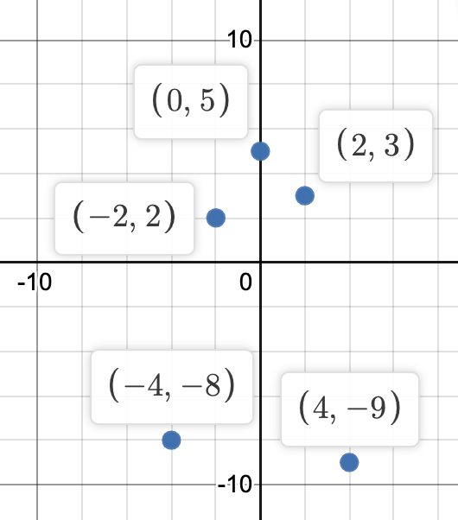
Domain: {-4, -2, 0, 2, 4}
Range: {-9, -8, 2, 3, 5}
This relation is a function.
- y = 3x – 3
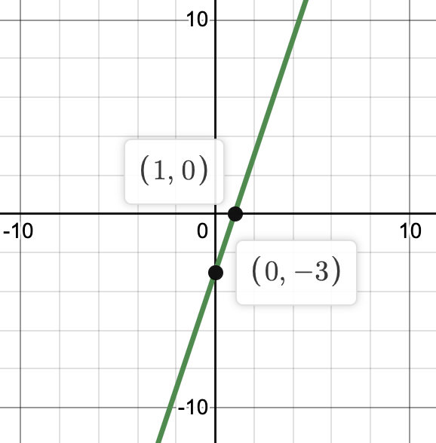
Domain: (-∞, ∞)
Range: (-∞, ∞)
This relation is a function.

Find the functional value.

- f(0) if f(x) = x – 3x²
f(0) = 0 – 3(0)²
f(0) = 0 – 3(0)
f(0) = 0 – 0
f(0) = 0

Graph each equation or inequality.

- y = ¾x – 2
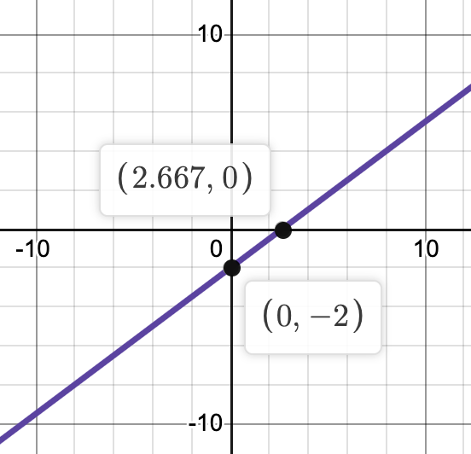
- f(x) = [[3x]] + 3
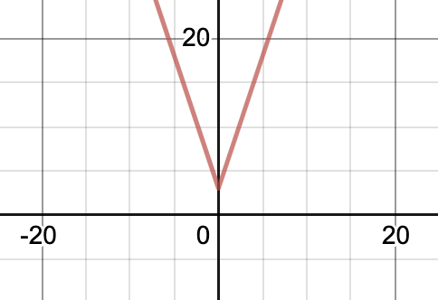
- y < 3|x – 2|
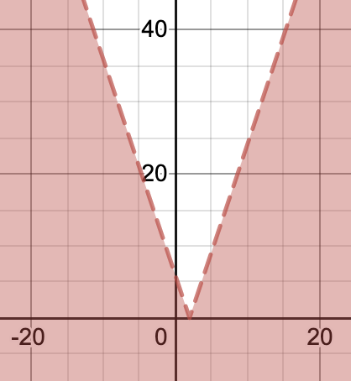

Find the slope of the line that passes through the two points.

- (5, -3), (6, 2)
m = (y2 - y1)/(x2 - x1) = (2 - (-3))/(6 - 5) = (5)/(1) = 5
5 is the slope.
- (-2, 5), (4, 5)
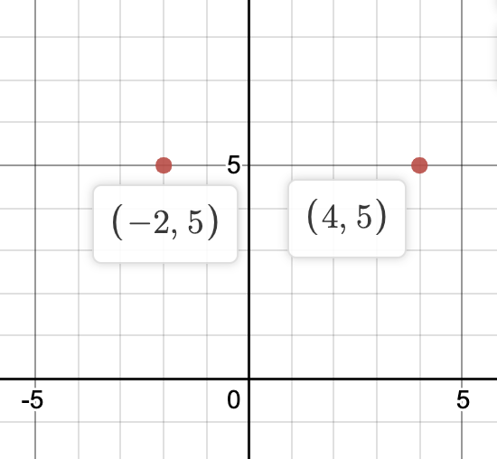
The graph shows that the slope is 0.

Write an equation in slope-intercept form for the line that satisfies each set of conditions.

- Passes through (-6, 15), parallel to the graph of 3x + 2y = 1
Slope-intercept form: y = mx + b
3x + 2y = 1
2y = 1 - 3x
y = ½ - (3/2)x so, m = -3/2
y = (-3/2)x + b
15 = (-3/2)(-6) + b
15 = 9 + b
15 - 9 = b
6 = b
So, the final equation that satisfies these conditions is: y = (-3/2)x + 6

Graph each system of inequalities. Name the coordinates of the vertices of the feasible region. Find the maximum and minimum values of the given function.

- 5 ≥ y ≥ -3
4x + y ≤ 5
-2x + y ≤ 5
f(x, y) = 4x - 3y
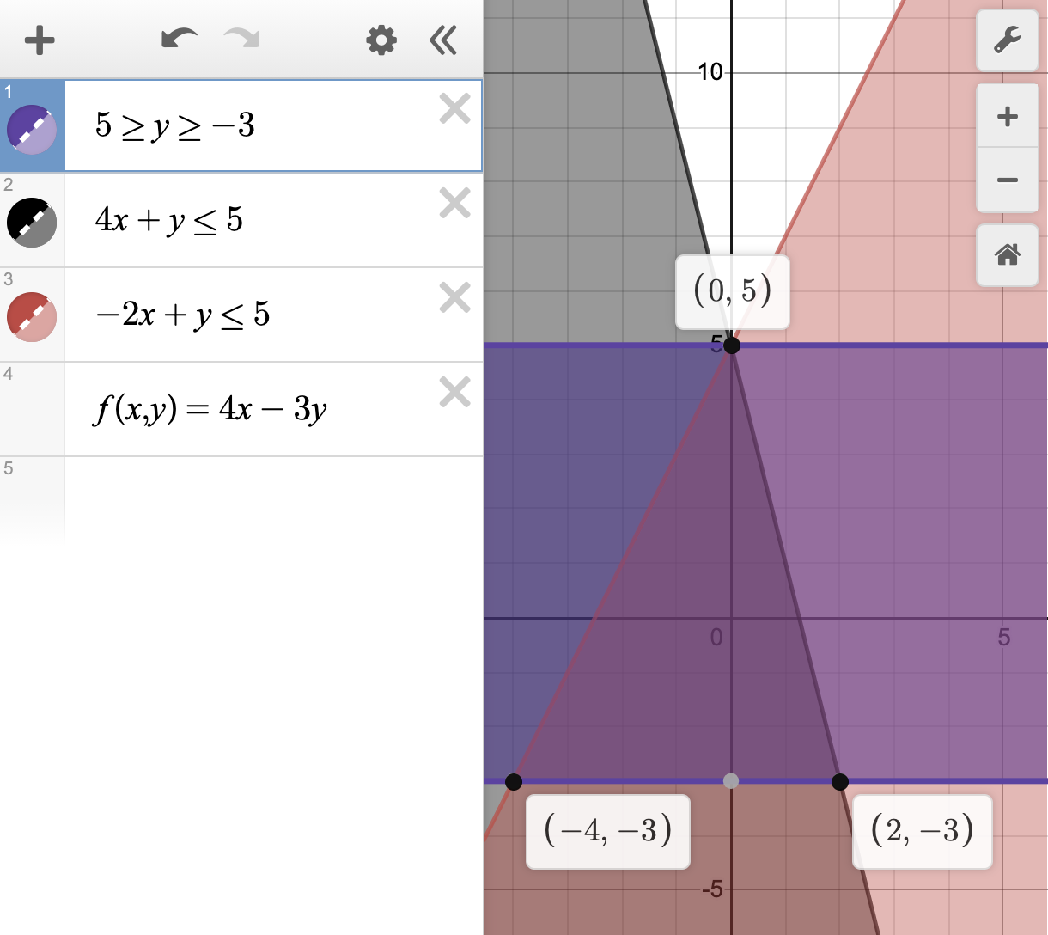
Vertices of the feasible region: (-4, -3), (0, 5), (2, -3)
Maximum: 5
Minimum: -3
- x ≥ -10
1 ≥ y ≥ -6
3x + 4y ≤ -8
2y ≥ x - 10
f(x, y) = 2x + y
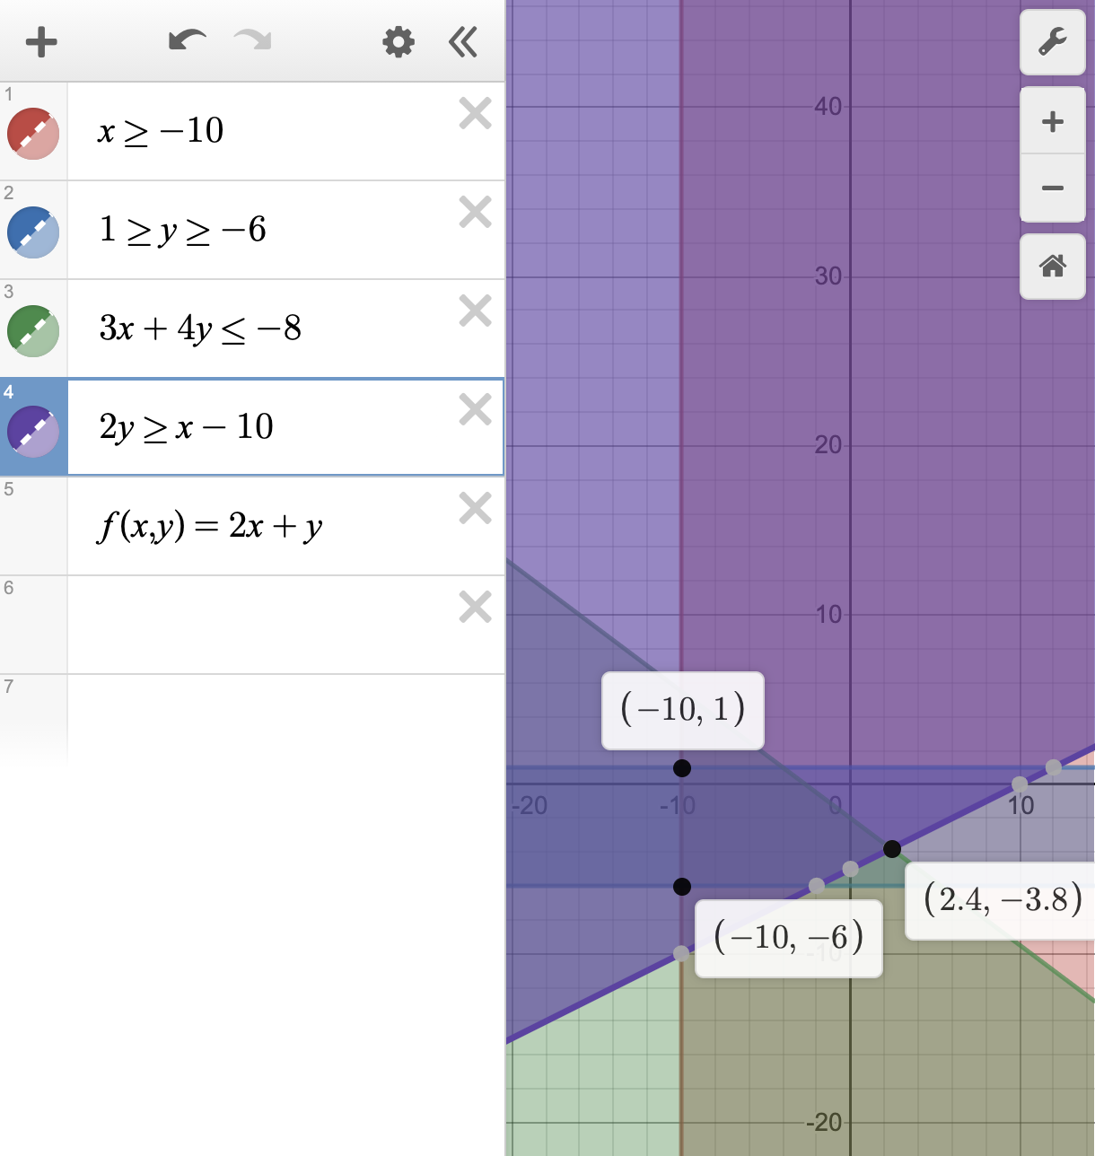
Vertices of the feasible region: (-10, -6), (-10, 1), (2.4, -3.8)
Maximum: 1
Minimum: -6

